EC2 MONITORING AND MANAGMENT

|  |  |
| --- | --- |
| Template details | |
| TOPIC | EC2 MONITORING AND MANAGMENT |

**AWS EC2 INSTANCE**

The document provides the high level guidance’s to setup the AWS EC2 Monitoring and Management on AWS Cloud.

**Assumption**

* Amazon Elastic Compute Cloud (Amazon EC2) provides scalable computing capacity in the Amazon Web Services (AWS) cloud. Using Amazon EC2 eliminates your need to invest in hardware up front, so you can develop and deploy applications faster. You can use Amazon EC2 to launch as many or as few virtual servers as you need, configure security and networking, and manage storage. Amazon EC2 enables you to scale up or down to handle changes in requirements or spikes in popularity, reducing your need to forecast traffic.

**Steps to launch EC2 Instance**

To launch the EC2 instance, you need to complete the following steps:

* Step 1: Login to your AWS account
* Step 2: [Choose an Amazon Machine Images(AMI) from Quick start](http://docs.aws.amazon.com/AmazonVPC/latest/UserGuide/VPC_VPN.html#vpn-create-vpg)
* Step 3: [Select Instance type](http://docs.aws.amazon.com/AmazonVPC/latest/UserGuide/VPC_VPN.html#vpn-configure-routing)
* Step 4: [Configure the all instance details](http://docs.aws.amazon.com/AmazonVPC/latest/UserGuide/VPC_VPN.html#vpn-configure-security-groups)
* Step 5: [Add storage to your instance](http://docs.aws.amazon.com/AmazonVPC/latest/UserGuide/VPC_VPN.html#vpn-create-vpn-connection)
* Step 6: [Create Sectuity group to your instance](http://docs.aws.amazon.com/AmazonVPC/latest/UserGuide/VPC_VPN.html#vpn-launch-instance)

**Create EC2 Instance**

1. Go to the EC2 Dashboard and click on Launch Instance.
2. Select Quick start instance – Amazon Linux [Note: As required you can select MyAMI’s / Marketplace / community AMI]

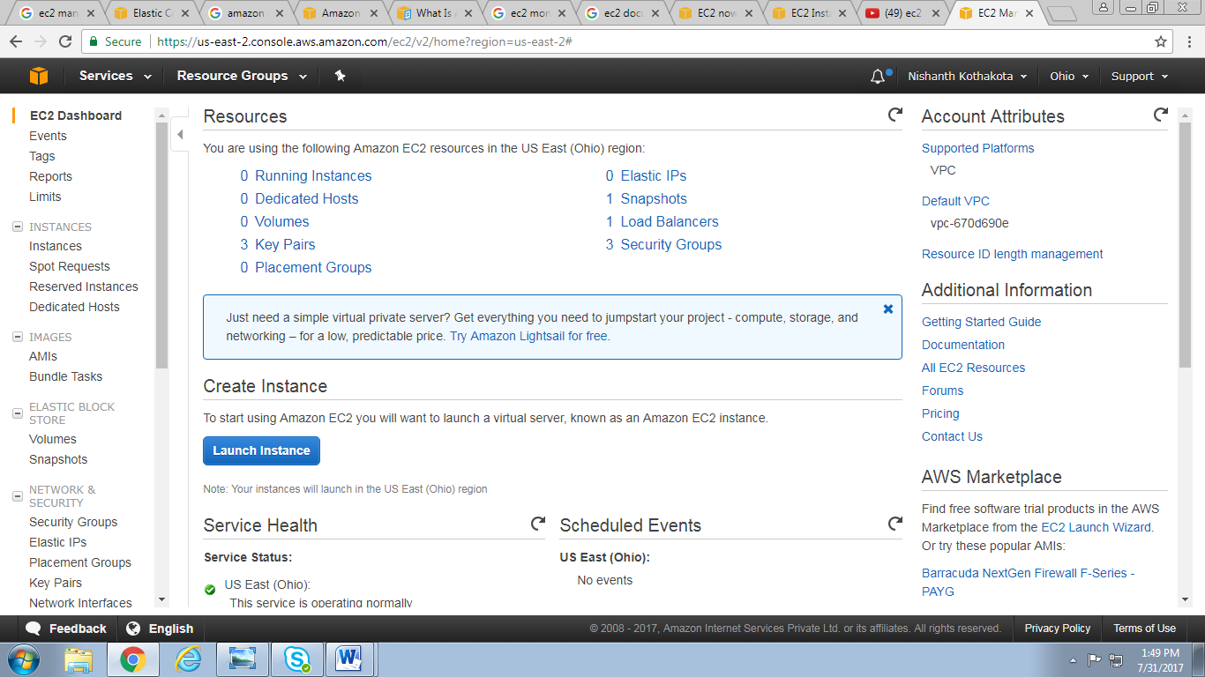

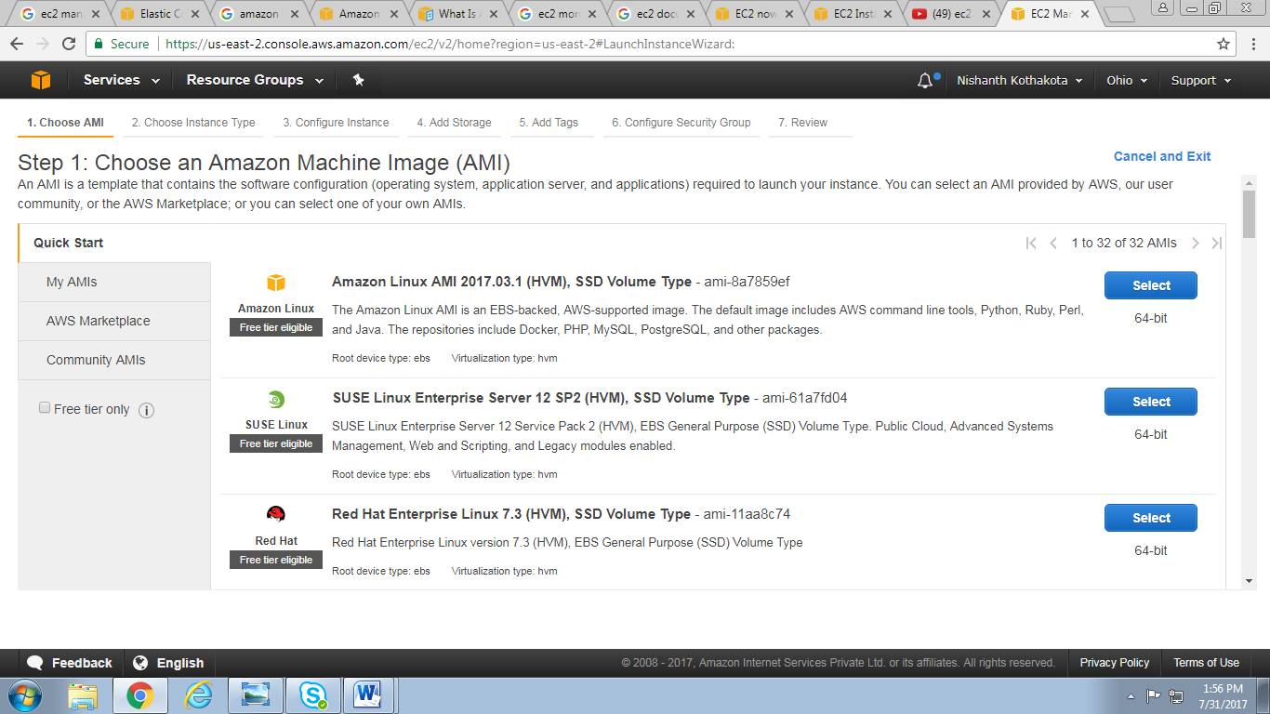

1. Select the Instance type as per the requirement and click on Next to start Configure Instance Details

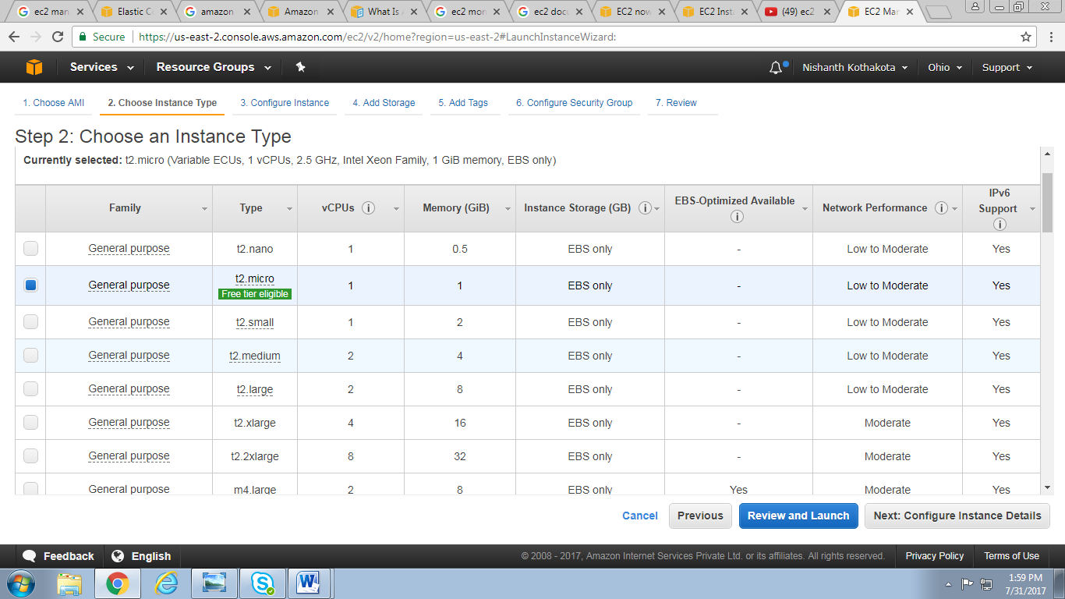

1. In Configure Instance tab select Network (Sample: VPCKumolus) .

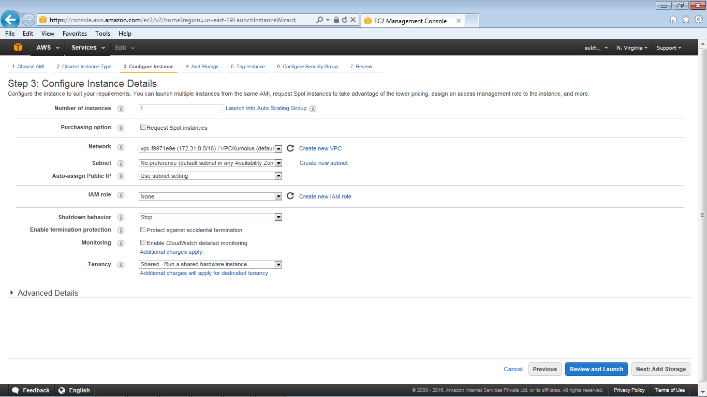

1. Select the default Subnet / Subnet as per available IP to be assigned

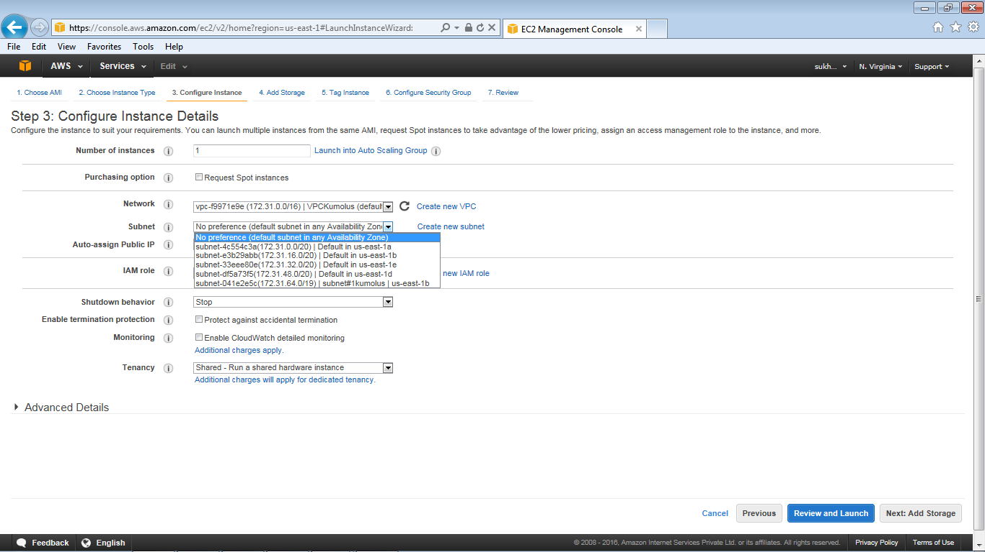

1. Select Auto-assign Public IP (Enable / Disable). This is required for services offered in AWS to work with the Instance.
2. Check option Protect against accidental termination under Enable Termination protection option.

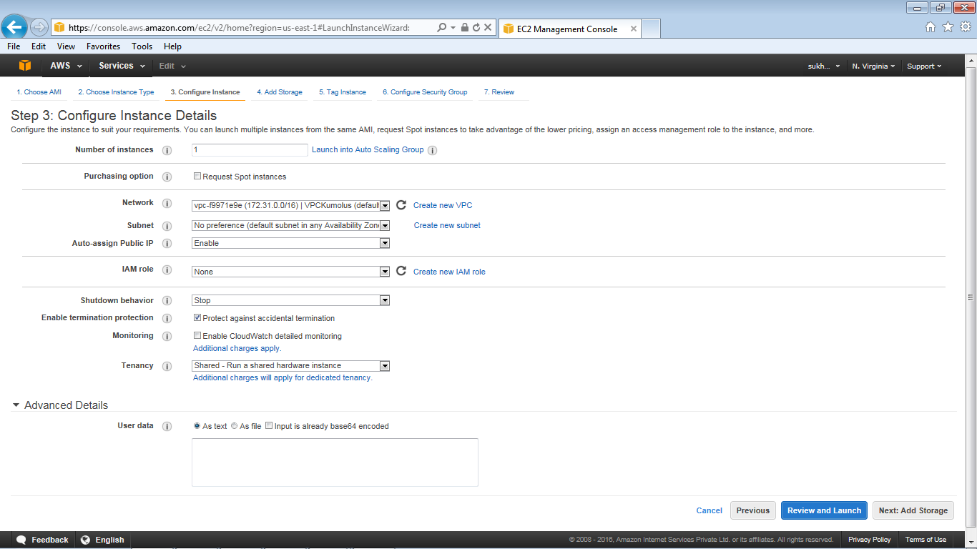

1. Proceed to next step to add Storage.
2. Select Volume type(General Purpose) as per the requirement and proceed to next step to add Tags to an instance. Other EBS Volume Type are EBS Provisioned IOPS (SSD) & EBS Magnetic

*http://aws.amazon.com/ebs/details/*

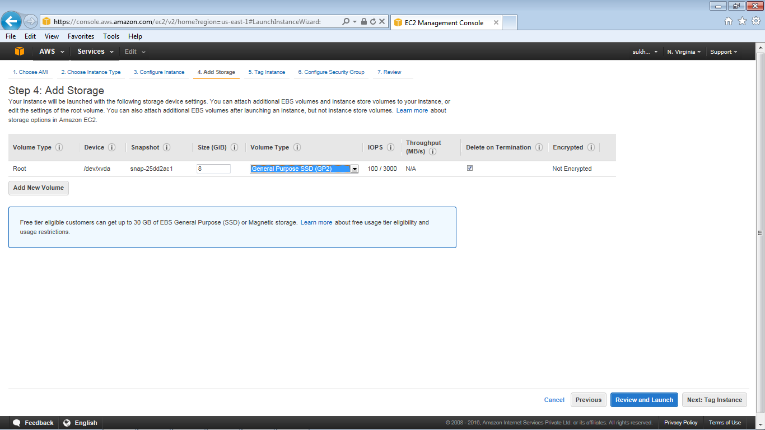

1. Tag Instance – provide the Key Value of the server and proceed now to next step to Configure Security group.

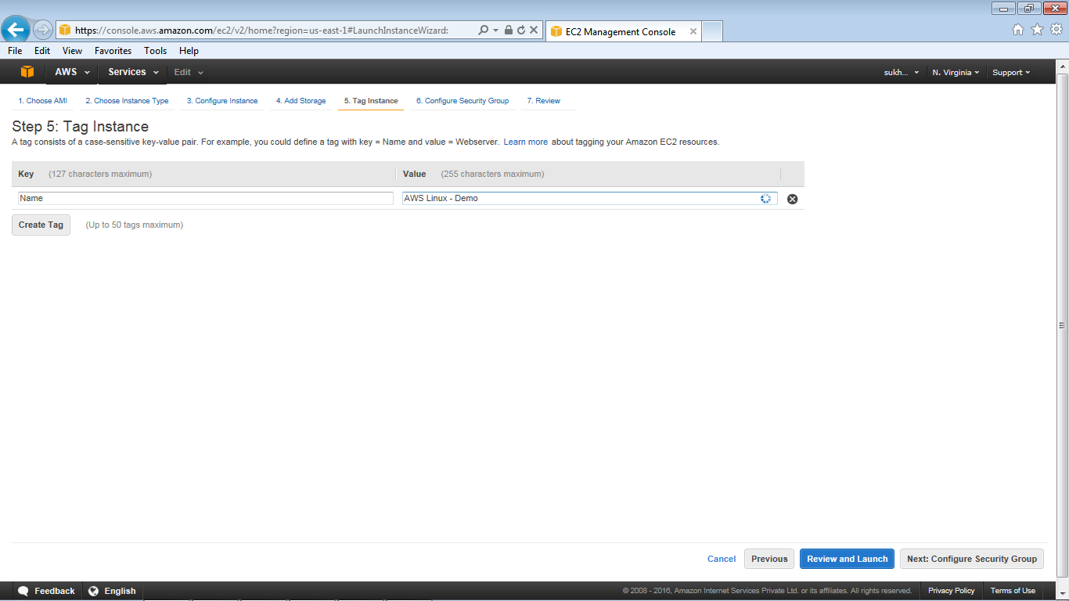

1. Create a new security group, provide the required protocals and proceed with Review and Launch.

(Note: if SG is already defined earlier then use option as Select existing security group)

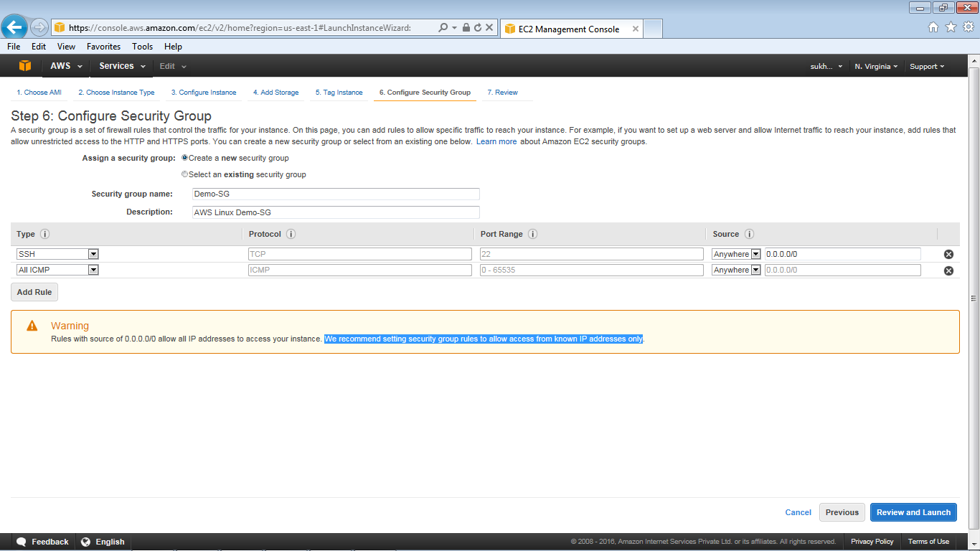

1. Review the instance details

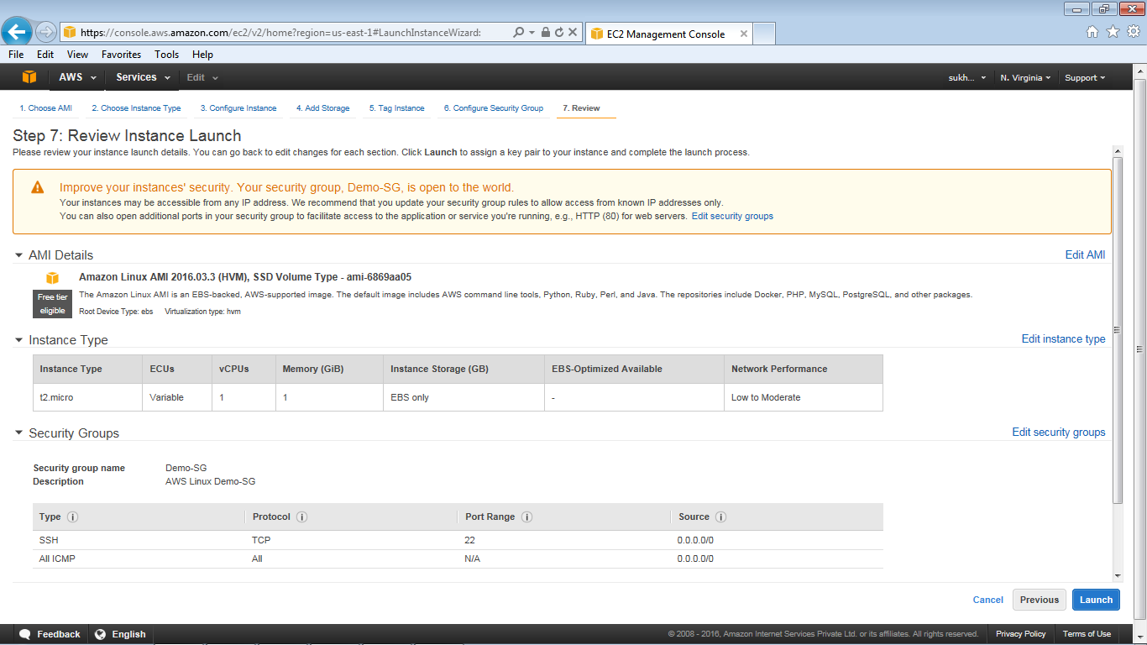

1. Select the option ‘choose an existing key pair’.

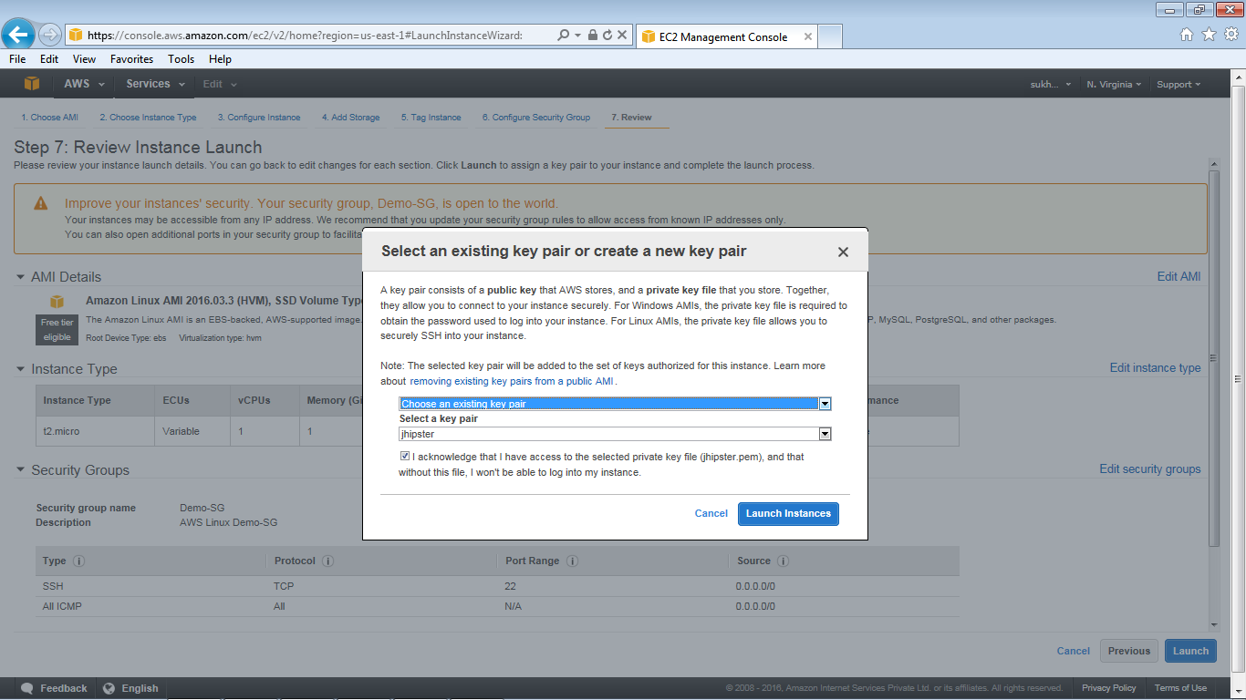

1. Select the existing key pair (Sample: Jhipster), Select I acknowledge checkbox and click on Launch instances.
2. The dashboard will show the Instance launch is in progress.

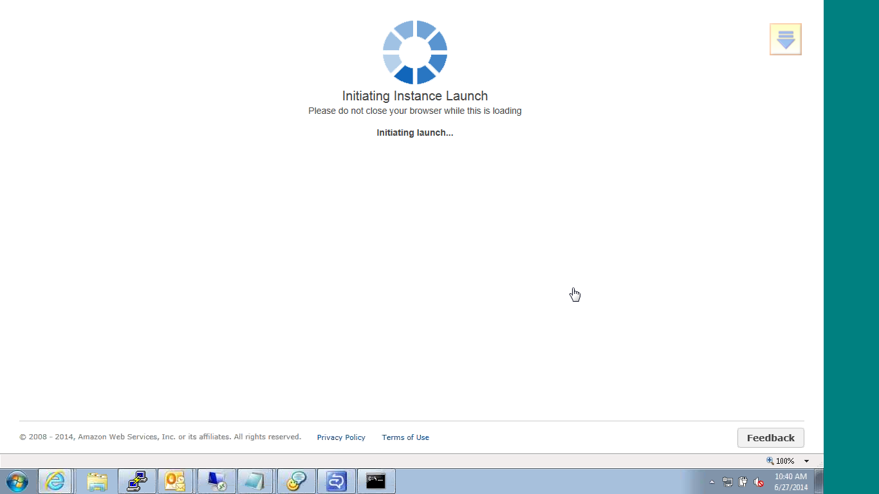

1. Click on view instances.

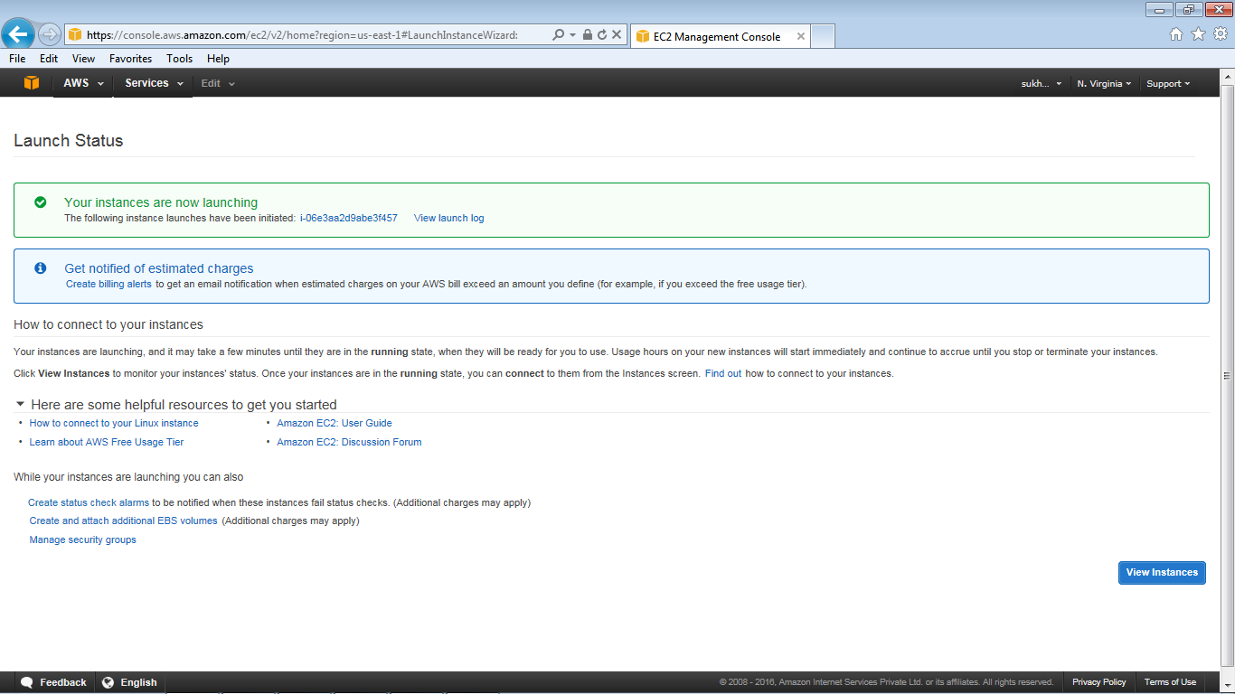

1. Initially the instance state is pending . It will change to running state once the VM build is complete and then the instance is ready to be accessed.

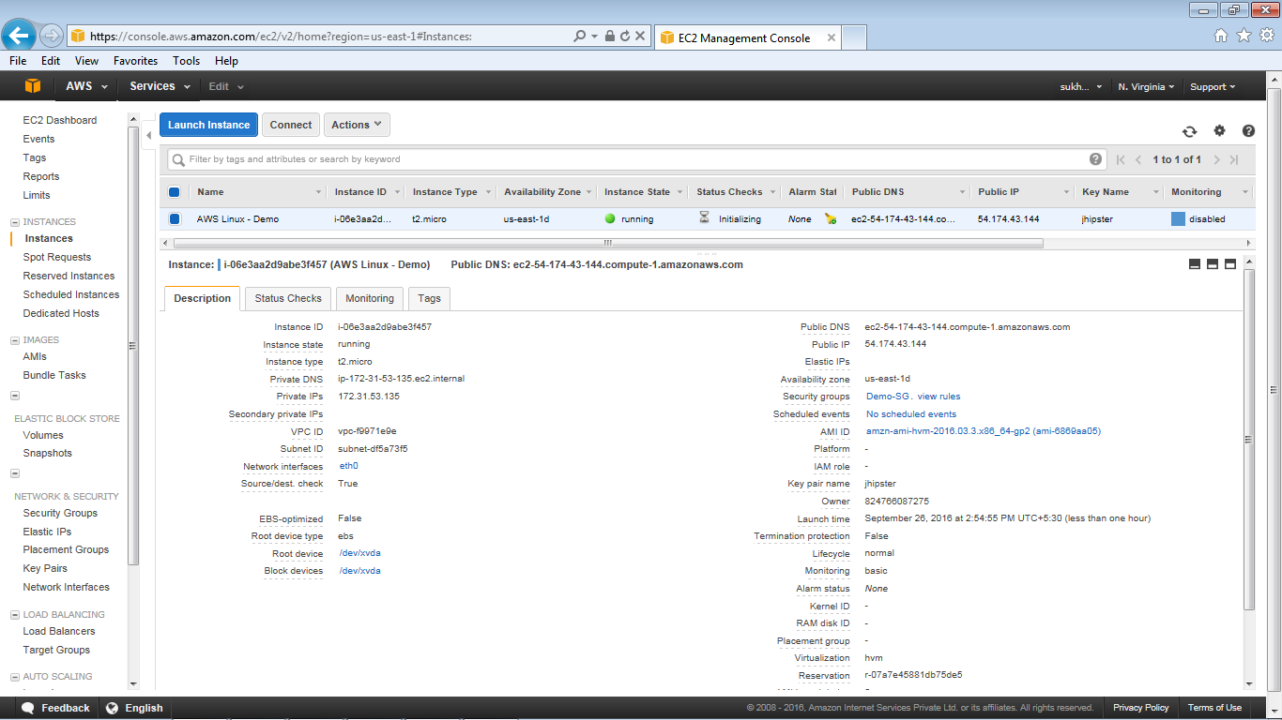

1. Select the instance which is created and verify the details. [Status code: 2/2 checks]

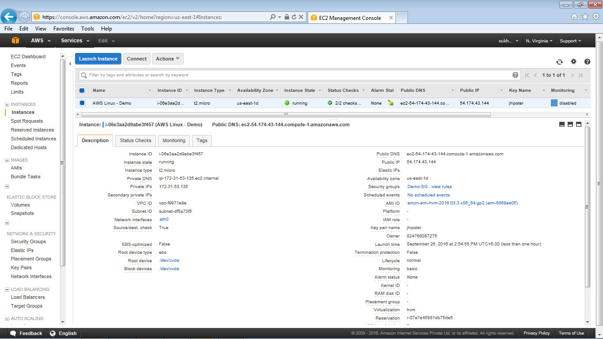

1. Access the instance using putty and login using Public DNS and ppk file.

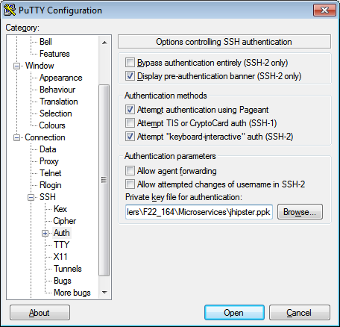

1. Login as ec2-user and press enter and check the disk space using “df -h”

Note: For security reason you can assign password while generating the ppk file using puttygen tool

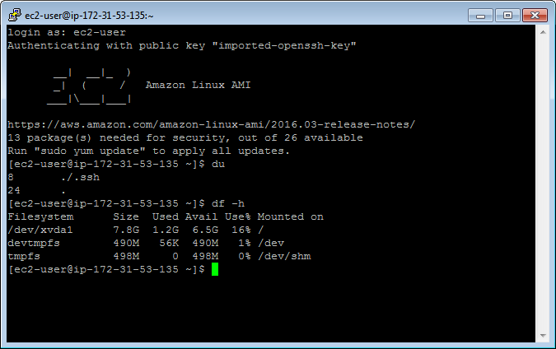

## Resizing the EC2 instance

1. Go to the EC2 Dashboard and select the intances
2. Choose **Actions**, select **Instance State**, and then choose **Stop**
3. In the confirmation dialog box, choose **Yes, Stop**. It can take a few minutes for the instance to stop

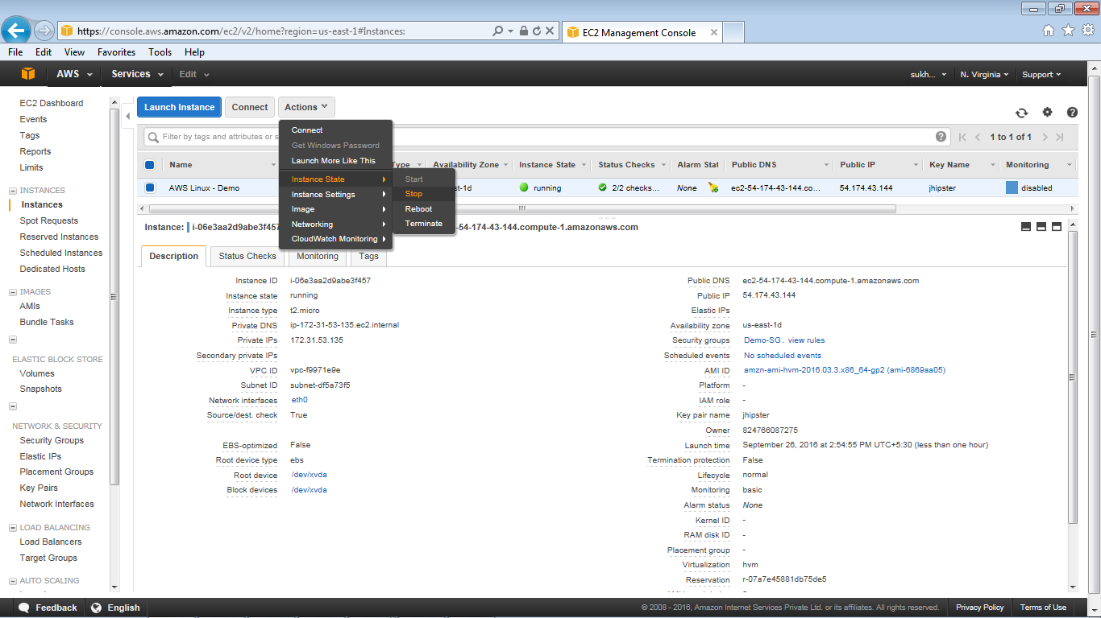

1. Instance status code is shown as “stopped”

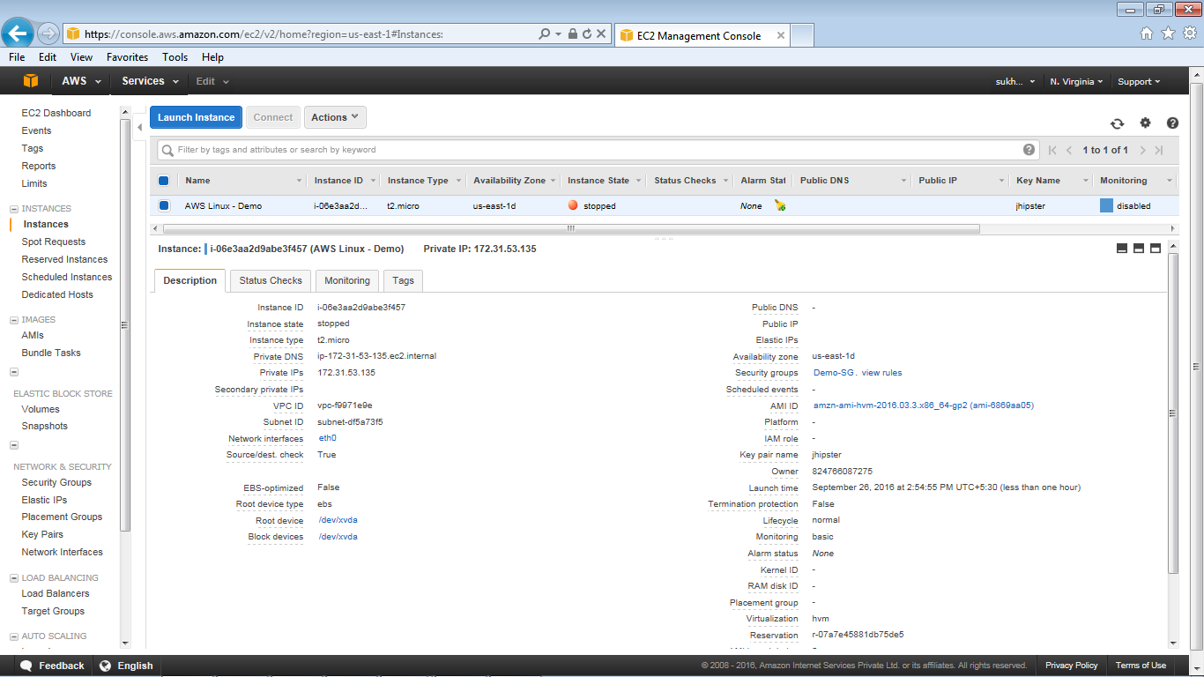

1. With the instance still selected, choose Actions, select Instance Settings, and then choose Change Instance Type. Note that this action is disabled if the instance state is not stopped

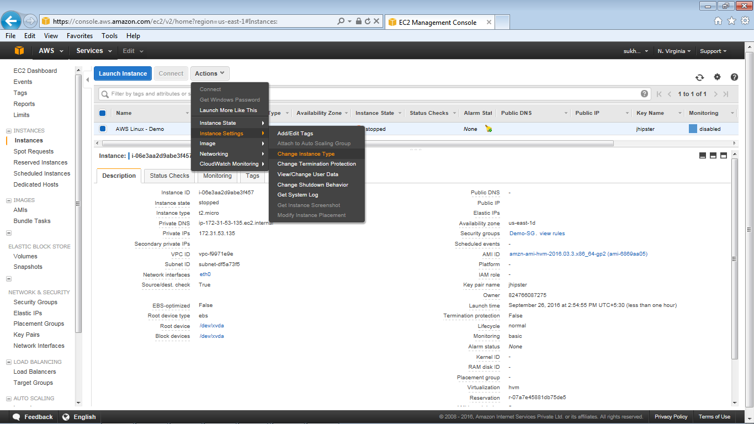

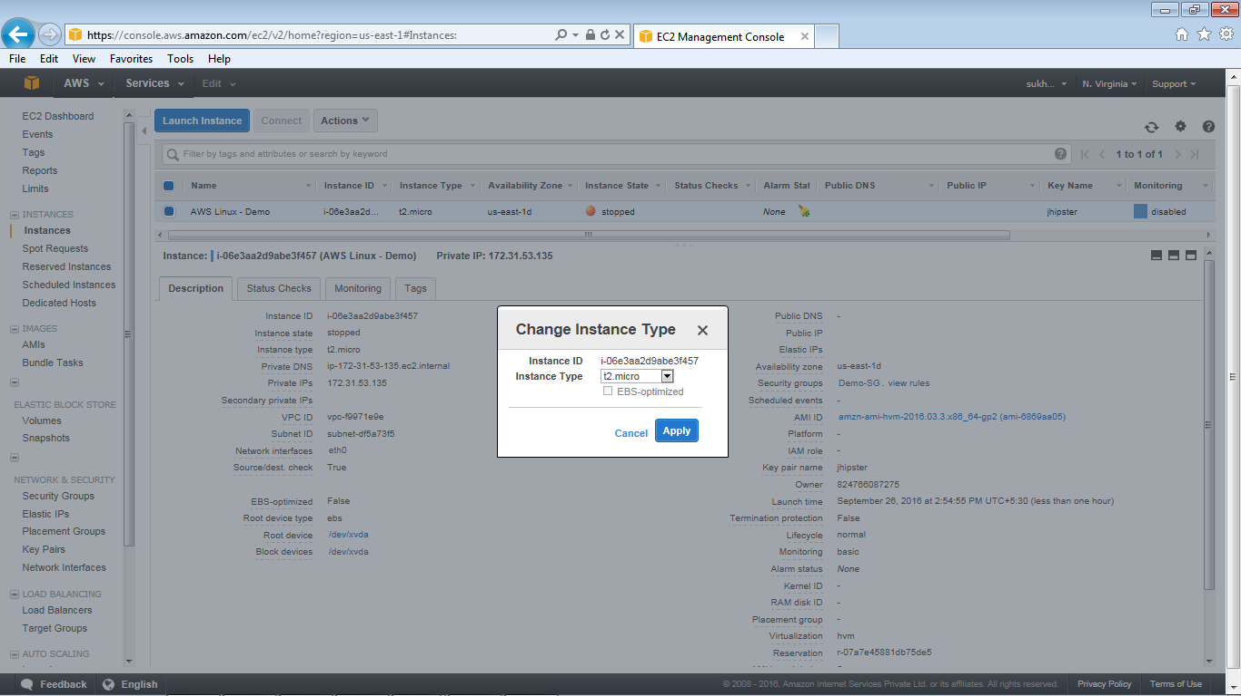

1. Click on apply button

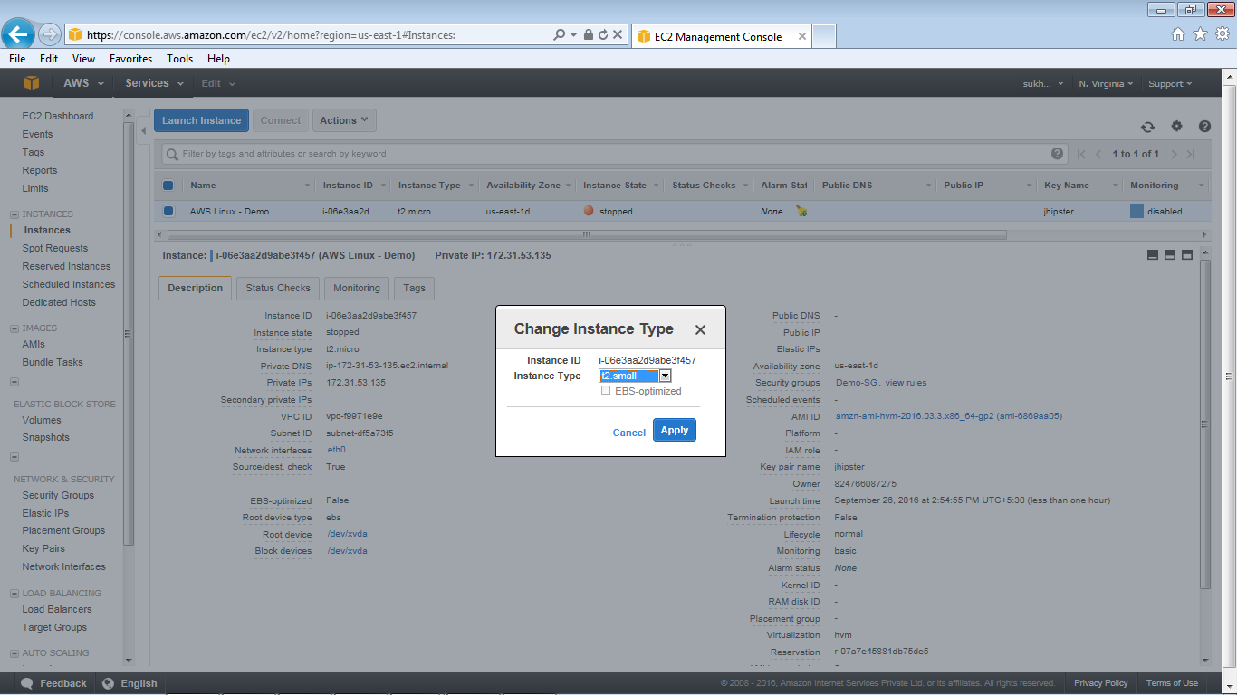

1. Choose Apply to accept the new settings. This resize the instance from (t2.micro to t2.small)

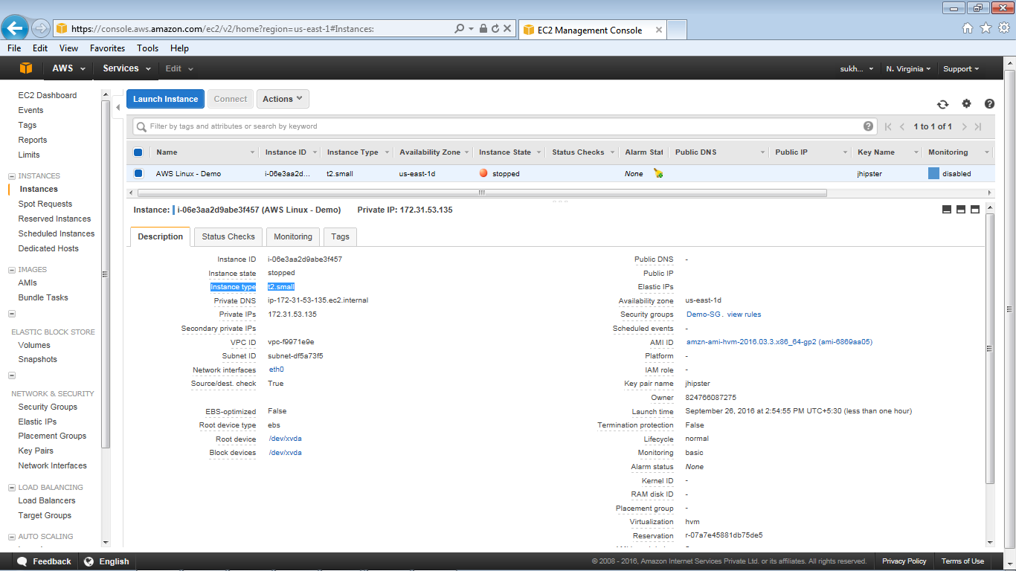

1. From Action option start the instance, login using putty and view the instances details

## Modify EC2 instance

1. Go to the EC2 Dashboard and select the intances
2. Start the instance (incase stopped)

Note: If EIP is not associated with the instance it will generate the new Public IP address)

1. Add/ Edit the Tags – Action – Add/Edit Tags

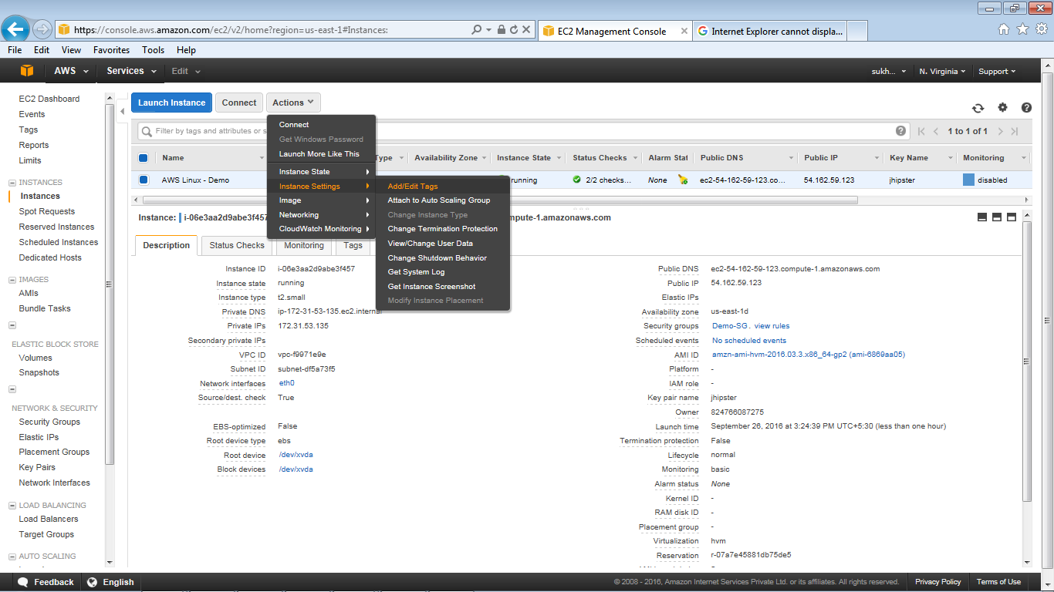

1. Add/ Edit the Tags of the instance and press save

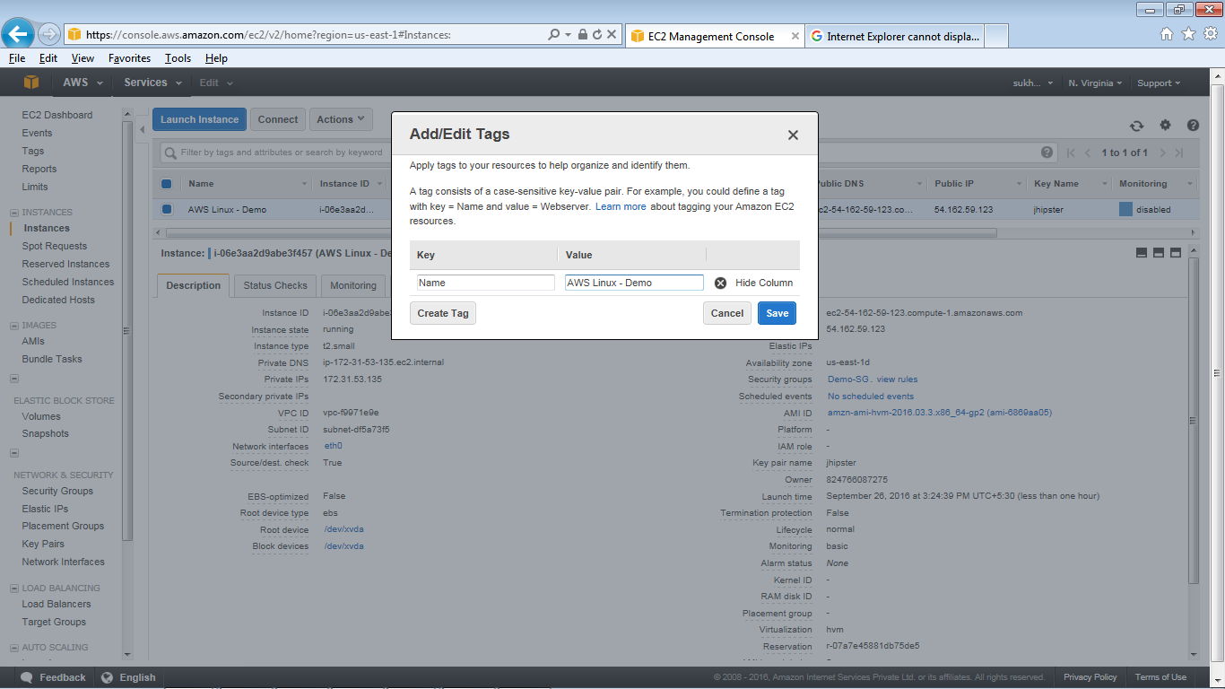

1. Reset the change Termination protection of the instance using “Yes Enable” button

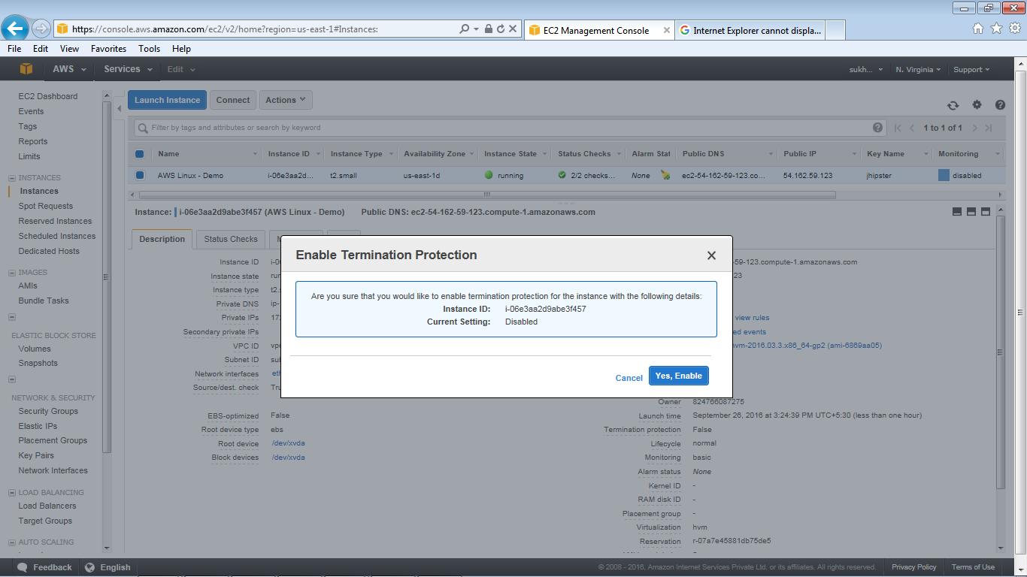

1. Reset the change the shutdown behavior of the instance selecting option “ Stop/Terminate”

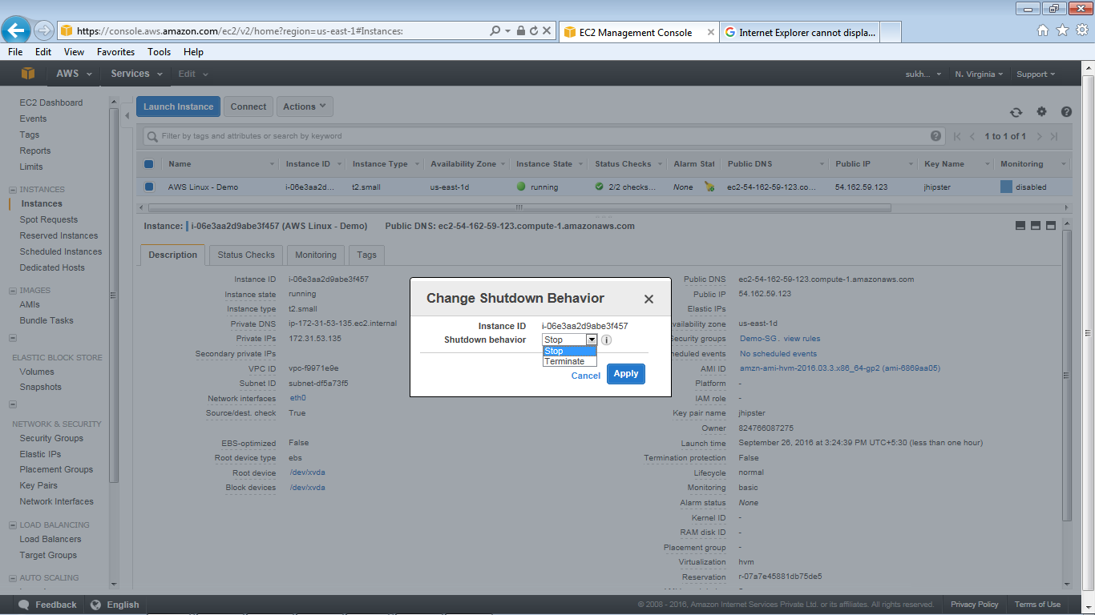

## Terminating EC2 instance

1. Go to the EC2 Dashboard and select the intances
2. From Action select Terminate option , it will show warning message

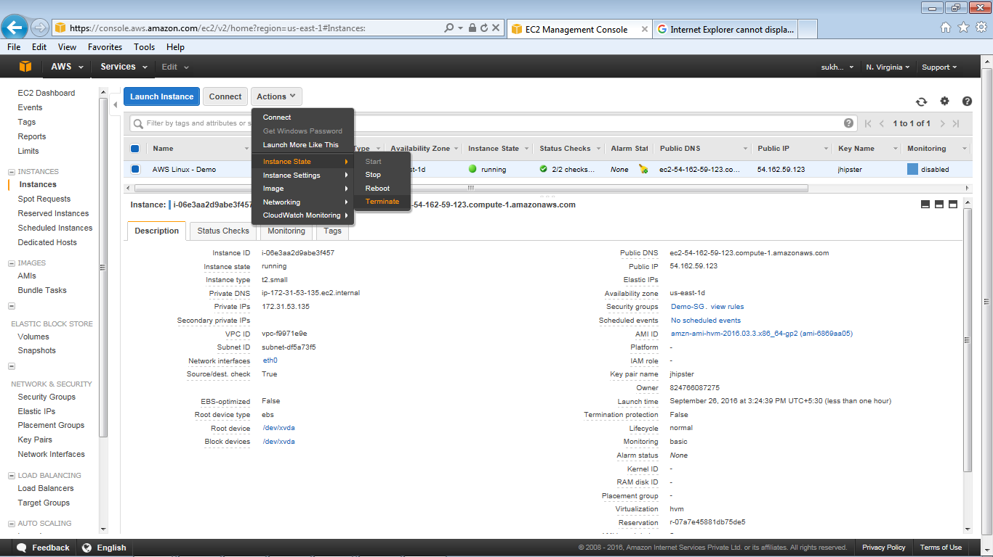

1. Press “Yes Terminate” button

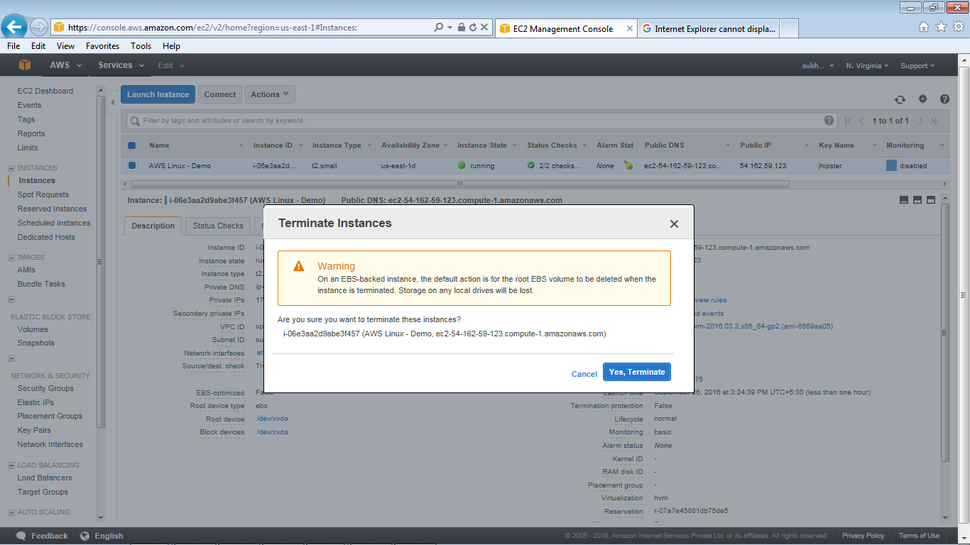

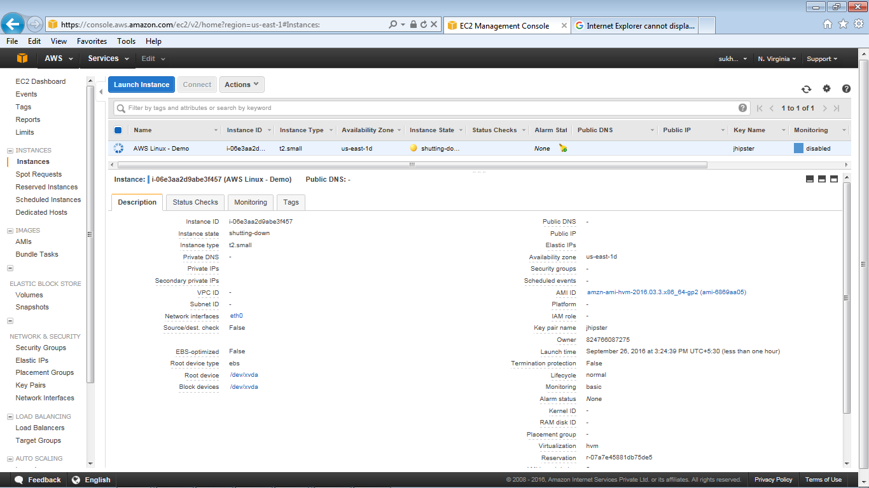

1. The Instance status code is changed to Terminated

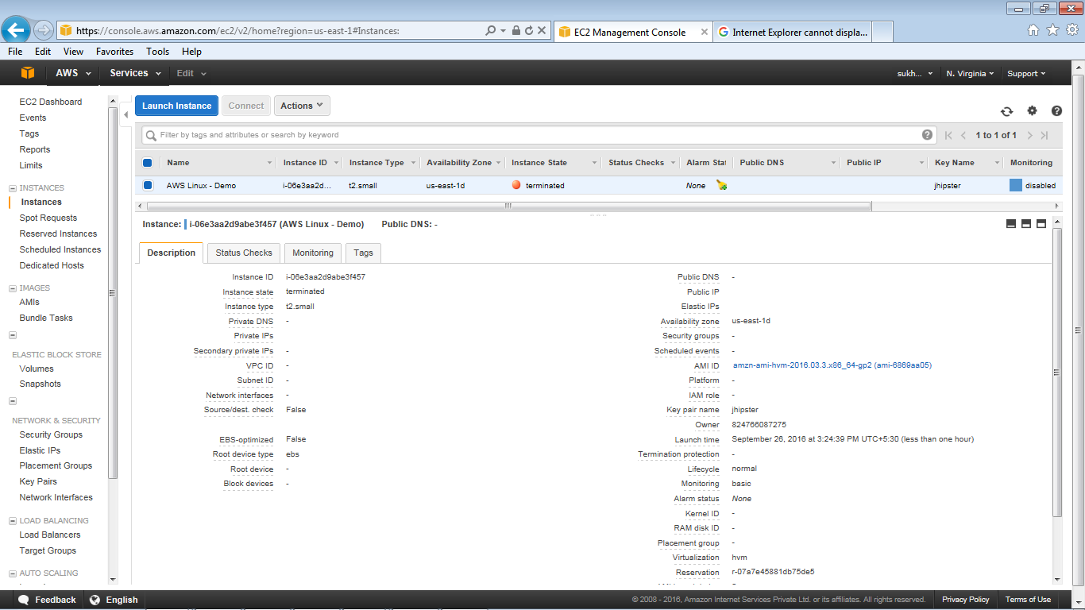

**MONITORING EC2 INSTANCE**

**STEPS TO MONITOR EC2 INSTANCE**

1. Log on the AWS console page and click on cloud watch

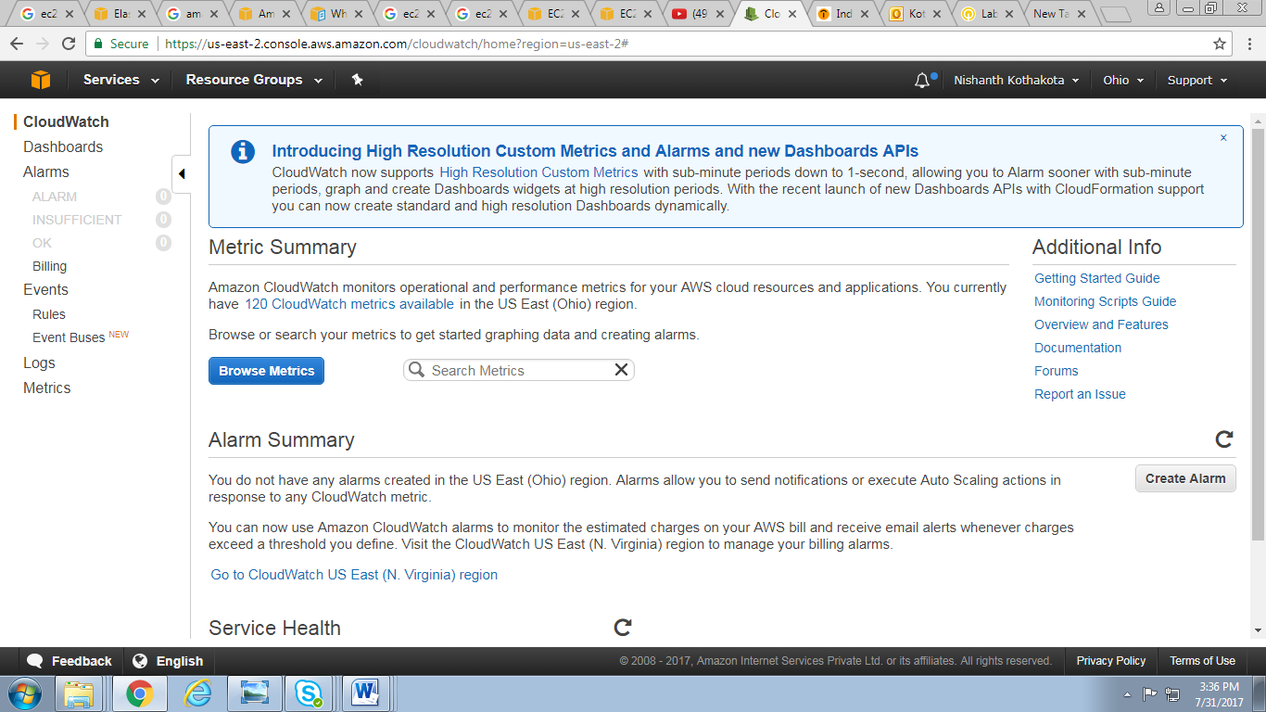

1. Click on Browse Metrics

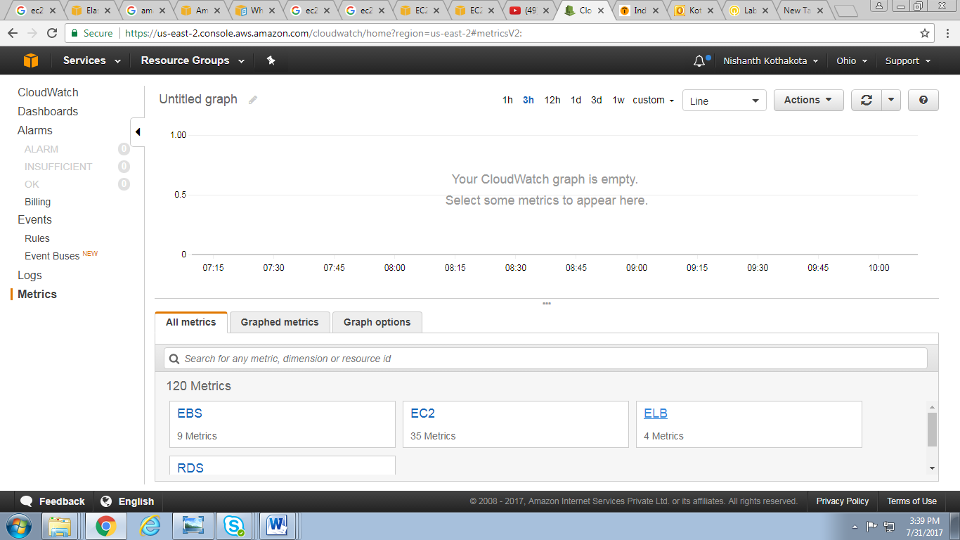

1. Click on Dash Board and create new Dashboard

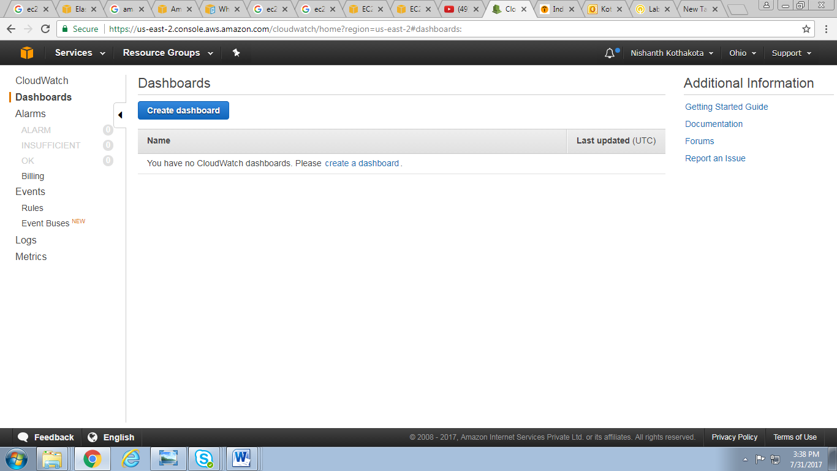

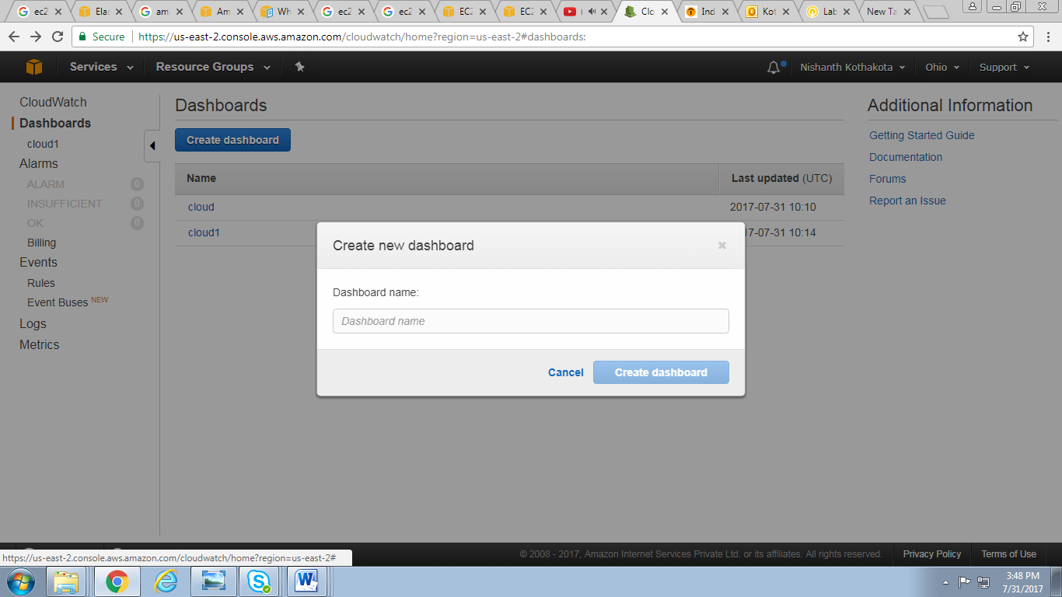

1. After that configure the metric graph and selct the instance

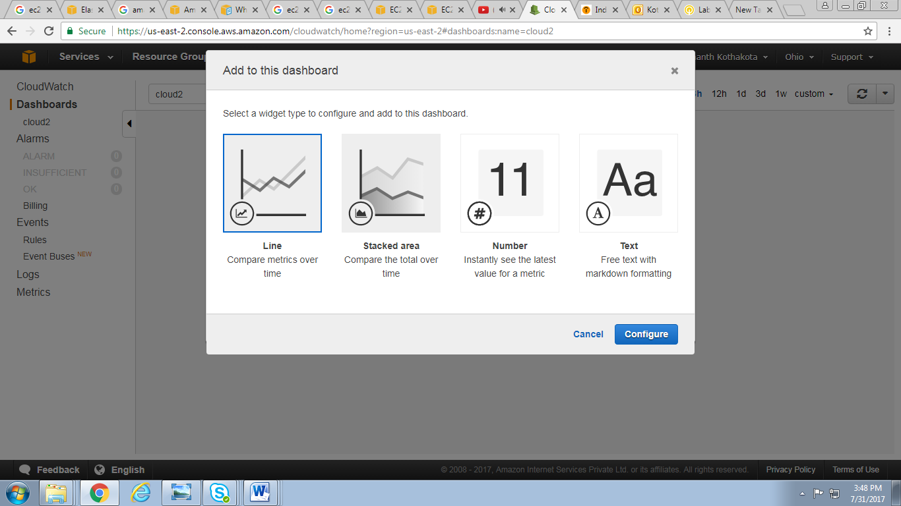

1. After adding the instance it shows utilization of instance

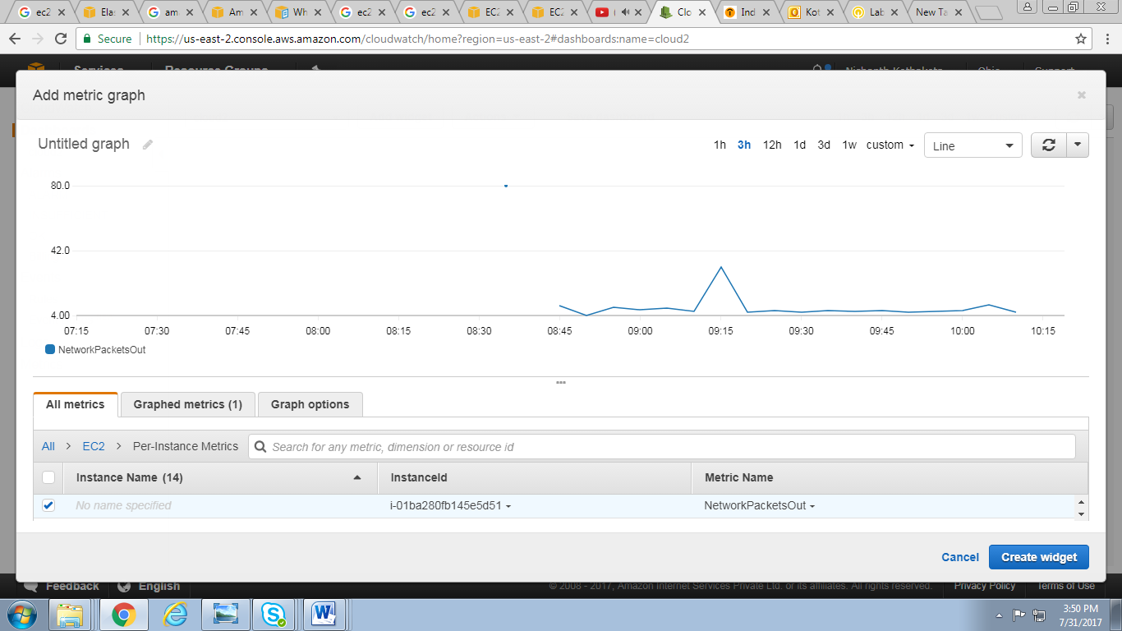

# References

<http://docs.aws.amazon.com/AWSEC2/latest/UserGuide/ec2-instance-lifecycle.html>

<http://docs.aws.amazon.com/AWSEC2/latest/UserGuide/putty.html>